PURPOSE
This policy defines the distribution and usage of Harold Stevens Athletic track locks and associated keys. A breach of this policy will result in keys being removed and the club sanctioned. The Harold Stevens track is a fenced venue leased from Moreland council and has 5 entrances in the perimeter fence, each consisting of a double gate and an associated single gate.
Within this boundary are 2 buildings =
1/ clubroom complex of cement brick construction at the southern end of the venue.
2/ A storage shed (bunker) of brick construction with a concrete roof and 2 secure roller doors located at the Northern end of the venue.
Currently there is a transport container at the South end also being used for storage.
Perimeter gates.
All entrance gates in the perimeter fence are normally padlocked using the general (or common) pad locks. These locks are the property of Ground Management.
The main entrance double gates (from the car park South end of the venue) also have a council issued padlock and a padlock associated with the waste collection company (JJ Richards). There is also a padlock associated with council Open Space division.
Any tradesmen doing extended work in the venue may have temporarily placed a padlock integrated with those mentioned.
Note – the general (or common) padlock enables keyholders of that lock, access to the venue at all times.
Note – Normal hours are defined as times the venue is officially booked for any activity.
Locks inside the perimeter
Nine padlocks are used within the perimeter around the track and infield. These are keyed to the general (or common) key. e.g. track lane protection gates, High Jump shed, power boxes.
The South end container is also on the general (or common key)
Storage shed (bunker)
The storage shed is a shared facility between CLAC and Harriers and has padlocks on the roller doors keyed separately to any other part of the venue.

MAP OF VENUE ENTRY POINTS
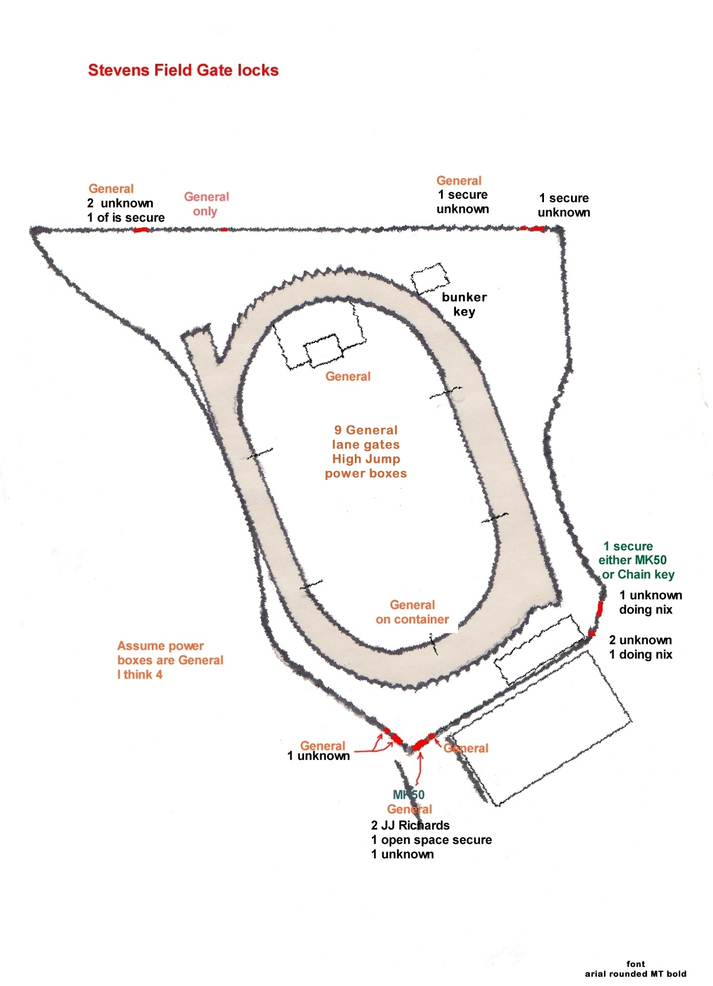

CLUB ROOM LOCKS
The club room pavilion has 4 external doors and 5 internal doors each having council security locks. A 5th external door is an emergency door which is openable only from the inside of the rooms and does not have a keyed lock.
Access to external toilet facilities attached to the rear of the club room, has both a council padlock and a general (or common) padlock on each entrance gate.

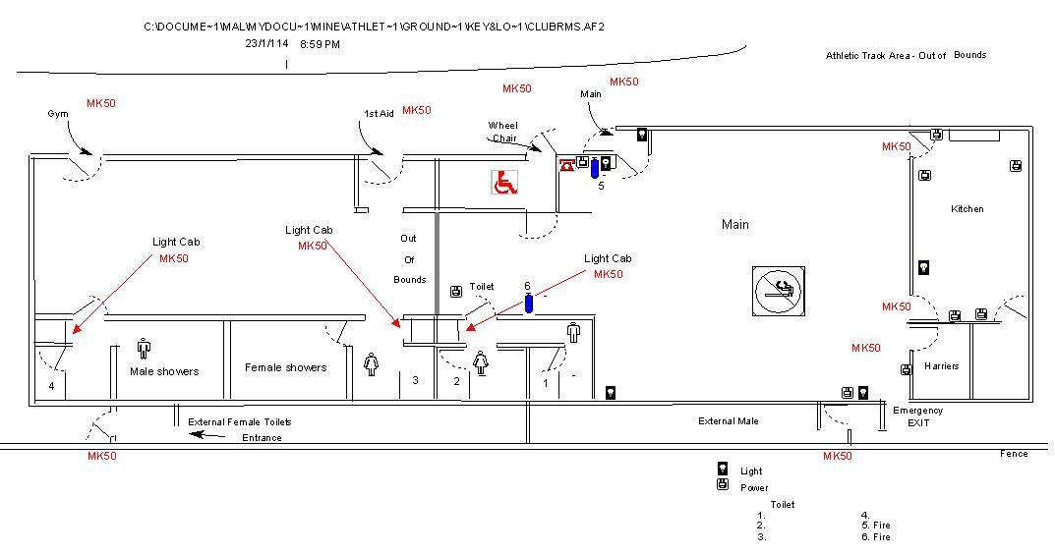
Plan of clubrooms showing location of doors having council master locks

KEYS:-
Each council lock is keyed to a council issued security master key system of Mother/Daughter arrangement labelled MKS50, MKS50A, MKS50B, MKS50C and MKS50D.
Council officers have access at all times to the venue and club room using this system.
The GENERAL KEY is a standard Yale type key- opens front gate, lane gates, jump sheds, External toilets & big container
The Master keys are security standard & open the following –
MKSC50 Key - Mother master key & opens all master locks.
MKSC50A Key - 1st Daughter master key & opens All outer doors (except the Gym West door) & Light cupboards . Does not open Harriers Storeroom or Canteen
MKSC50B Key - 2nd Daughter master key & opens All outer doors (except the Gym West door) . Does not open the first aid room into the gym, Harriers store room or switchboard cupboard
MKSC50C Key - 3rd Daughter master key & opens All outer doors (including the Gym West door , disabled toilet & first aid room) & kitchen but not external toilets or Harriers store room
MKSC50D Key - 4th Daughter master key & opens Rooms & Kitchen
Pictures show the common or general key and the council issued master key MKSC50
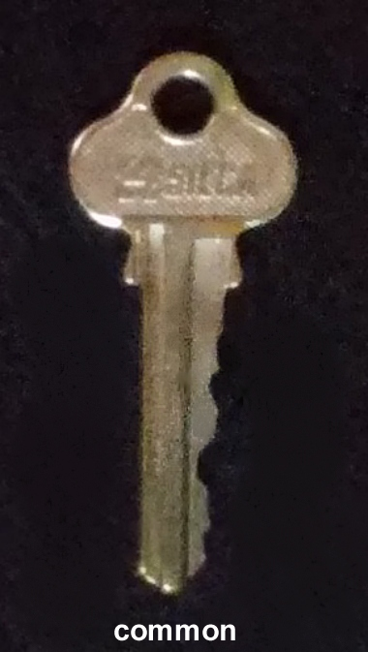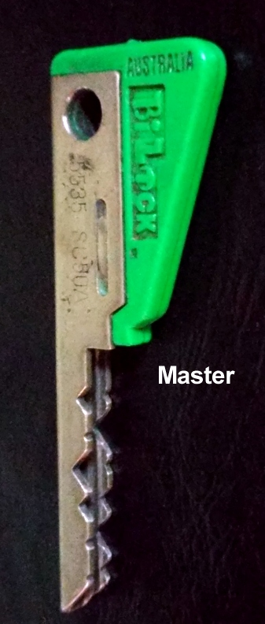

POLICY STATEMENTS
- All keys and locks for the Harold Stevens Athletic Track are the responsibility of the Coburg Athletic Ground Management Committee (CAGMC). Any non-sanctioned locks will be removed.
- Each Tenant club and the CAGMC committee are issued by the committee with a set of keys for distribution to their office holders and members for athletic purposes. Clubs may make provision for persons who require access out of normal times. ( Tradesmen access, maintenance work, private training, gymnasium access, etc.) Not to be used for non-sanctioned personal use.. See also provisions of the Use of Venue Policy at https://1clickurls.com/jitnQpv
- Note – all reference to “club” includes CAGMC
- Under the terms of the CAGMC lease with Moreland council CAGMC Secretary will provide council with name and contact details of each keyholder.

PROCEDURES
The CAGMC Secretary will:

- Be responsible for recording where and what type of locks are associated with the venue.
- Keep an up to date record of each key, keyholder, a description of the keys they hold and their contact details.
- Make the complete record available to CAGMC committee on demand
- Provide council with the list of keyholder details under conditions of the lease.’
- Require an annual check of the keys by written/email request to each tenant club’s Secretary.
- Keep a master set of labelled keys for comparison and to provide access for tradesmen and deliveries outside of normal times.
- Hold all keys along with the master set that are not currently being used for the purpose designated.

The tenant club’s will:

- Be responsible for keeping a record of the details of each of their keyholders, and the location of all keys issued to them
- Provide back to the CAGMC Secretary any changes that occur with regard to keys or keyholders within 48 hours of such changes.
- Be responsible for the return of keys, which are no longer required by their club, to the CAGMC Secretary within 7 days of the change in use.
- At CAGMC’s request be responsible for carrying out a key check of their club’s keyholders and returning results to CAGMAC Secretary within 7 days.
CAGMC Secretary to provide clubs with the most recent check list in a suitable format.

The keyholders will:

- Be responsible for the secure keeping of all keys they have been issued.
Key holders will lose the privilege of having keys where, in the opinion of CAGMC or their tenant club they have misused, allowed copies to be made or have been determined to be careless in the case of a lost key.
- Notify their club within 7 days of any change to the status of their key holding including changes of their contact details.
- Ensure their use of keys is in accord with this policy.
- Return their keys to their club immediately on request from their club Secretary.
Non return of keys on request may involve a report to police.
- Will ensure that all use of their keys is conditional on ensuring the venue is fully secured at the end of activities within the venue.
Key holders will lose the privilege of having keys where, in the opinion of CAGMC or their tenant club they have failed to do so.

Special Procedures:

As of 2019 individual athletes wanting access to the venue and/or toilet facilities outside normal hours will apply through their club committee who will make a request to CAGMC for issue of a “General/common” key which CAGMC Secretary will record in the key register and a surety of $50 charged.

